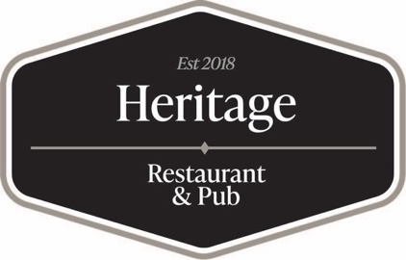

To Our Friends, Loyal Patrons and The Community of Supporters:

It is with a Heavy Heart that we Announce that HERITAGE RESTAURANT & PUB Will Be Closing Our Doors at 8:00pm on Friday June 5th.

This Decision has not been made lightly nor easily. But over the course of the last 2 weeks we lost two Key Members of our Kitchen/Back of House Team. Chef Erik Dressler tendered his resignation effective the end of this week and our main line cook has already left. We cannot continue to operate under these conditions and as most people are aware, finding the caliber of personnel needed to run a restaurant with the excellence you’ve come to know and expect from HERITAGE is not easy nor readily available. Therefore, we simply cannot continue to move forward and grow.

We are so appreciative of all of the Love and Support from the Shamokin, Northumberland community and from those who traveled from outside of the region to support us and our team – It has truly been an honor and privilege to serve you! We have made many friends and acquaintances throughout this journey and for that we express our enduring thanks and gratitude for the relationships that have made an impact on our lives and we will forever hold in our hearts and memories. We are equally appreciative of our Amazing Team of Dedicated People that have put so much into making Heritage what it has become and the incredible food and service they have consistently delivered.

We have proven that something truly special can be built in this community and we hope and pray that whomever purchases the restaurant will take it to the next level and provide this community with something truly special and deserving!

With Friday, June 5th being the last day … we are going to be offering SPECIALS on ALL Items – Food & Drink to move some inventory and to say THANK YOU for all of the support over these past 3 ½ Years we’ve owned and operated HERITAGE! Please Stop In and Take Advantage of these Blow-Out, Discounted Prices, Have A Drink In Honor of ALL That We Have Accomplished Together and Give Us The Opportunity To Say Good-Bye to the Many Friends we have made on this Journey we have taken together!

We are not going anywhere! Please come to OLIVER’S and continue to support us there as we look to grow, expand and increase our presence in Shamokin and beyond!

With Love and Affection,

Edward & Wendy Manning

